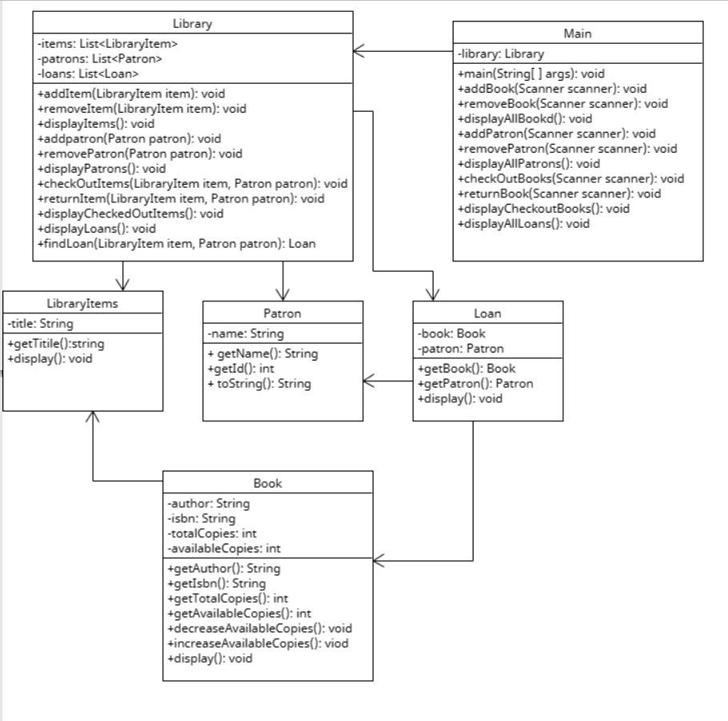

Fig: UML Class diagram

This UML diagram includes all the functions inside the class as well as relations between them. There are certain description of all the methods that were described inside the class. They are as follows:

1. LibraryItem:

* This class represents a generic library item. It has a single attribute called "title" of type String, which represents the title of the library item.
* The class provides two methods:
* getTitle(): This method returns the title of the library item.
* display(): This method displays the details of the library item.

2. Book (extends LibraryItem):

* This class represents a book, which is a specific type of library item. It extends the LibraryItem class, inheriting its attributes and methods.
* In addition to the inherited "title" attribute, the Book class introduces the following attributes:
  + author: Represents the author of the book and is of type String.
  + isbn: Represents the International Standard Book Number (ISBN) of the book and is of type String.
  + totalCopies: Represents the total number of copies of the book available in the library and is of type int.
  + availableCopies: Represents the number of available copies of the book for loan and is of type int.
  + The Book class provides several methods:
  + getAuthor(): This method returns the author of the book.
  + getIsbn(): This method returns the ISBN of the book.
  + getTotalCopies(): This method returns the total number of copies of the book.
  + getAvailableCopies(): This method returns the number of available copies of the book.
  + decreaseAvailableCopies(): This method is called when a book is checked out, and it decreases the count of available copies.
  + increaseAvailableCopies(): This method is called when a book is returned, and it increases the count of available copies.
  + display(): This method displays the details of the book.

3. Patron:

* This class represents a patron or a library member. It has two attributes:
  + name: Represents the name of the patron and is of type String.
  + id: Represents the ID of the patron and is of type int.
* The Patron class provides the following methods:
  + getName(): This method returns the name of the patron.
  + getId(): This method returns the ID of the patron.
  + toString(): This method returns a string representation of the patron.

4. Loan:

* This class represents a loan, which associates a book with a patron. It has two attributes:
  + book: Represents the book being loaned and is of type Book.
  + patron: Represents the patron who has borrowed the book and is of type Patron.
* The Loan class provides the following methods:
  + getBook(): This method returns the book being loaned.
  + getPatron(): This method returns the patron who borrowed the book.
  + display(): This method displays the details of the loan.

5. Library:

* This class represents a library and manages the library items, patrons, and loans. It has the following attributes:
  + items: Represents a list of library items and is of type List of LibraryItem.
  + patrons: Represents a list of patrons and is of type List of Patron.
  + loans: Represents a list of loans and is of type List of Loan.
* The Library class provides various methods to perform operations on the library:
  + getItems(): This method returns the list of library items.
  + getPatrons(): This method returns the list of patrons.
  + addItem(LibraryItem): This method adds a library item to the collection by taking an instance of LibraryItem as a parameter.
  + removeItem(LibraryItem): This method removes a library item from the collection by taking an instance of LibraryItem as a parameter.
  + addPatron(Patron): This method adds a patron to the collection by taking an instance of Patron as a parameter.
  + removePatron(Patron): This method removes a patron from the collection by taking an instance of Patron as a parameter.
  + checkOut(LibraryItem, Patron): This method performs the checkout process by taking a library item and a patron as parameters.
  + returnItem(LibraryItem, Patron): This method performs the return process by taking a library item and a patron as parameters.
  + displayItems(): This method displays the details of all library items.
  + displayPatrons(): This method displays the details of all patrons.
  + displayLoans(): This method displays the details of all loans.
  + findLoan(LibraryItem, Patron): This method finds a loan based on the associated library item and patron.

6. Main:

* This class contains the main method and serves as the entry point for the program. It provides various methods to interact with the library system, such as adding books, removing books, adding patrons, checking out books, returning books, and displaying information.